Case Study 13.3: FCL using Boost by; Claire Campbell, AAPS Users 24Feb.2024_V.2
Subject:
Freya - 7 years old
TTD 22U
Weight 26kg
T1 for 2 years
Novo-Rapid

Profile Settings:
Target 5.5
Carb Ratio 15
ISF 8.5
Basal varies between 0.35-0.50 per hour
DIA 9 hours

Hardware:
Dexcom G6 – Anubis Transmitter. Freya gets about 15-18 days from 1 sensor.
Medtrum Nano 200u patch pump. Freya get 5-6 days from 1 patch.

Software:
Tim2000s/Boost_AAPS_3.2 version of AAPS.

Boost Settings:
Boost Insulin Required 70%
Boost Cap 1.1U
Percent Scale Factor 200
Boost Scale 1.0
UAM Boost Max IOB 4U
Boost Start Time 0645
Boost End Time 2000
Max Minutes of Basal to Limit SMB to for UAM 20min

Introduction

The purpose of this case study is to demonstrate the effectiveness of Boost AAPS version in managing a child’s Fully Closed Loop (FCL).

Background

A FCL does not require any carb entering or manual bolus.

The goal for Freya is to achieve a FCL that allows her to consume a higher carb diet while maintaining time in range (TIR) >95%.

Problem

Without pre-bolusing, the most recent Master version of AAPS does not deliver enough insulin from Super Micro Boluses (SMBs) to cover a meal or a snack for Freya. This is primarily due to her low basal rate of 0.35-0.50 units per hour. I had set SMB and Unannounced Meal (UAM) durations to 120 minutes and adjusted the "Max daily safety multiplier" from 3 to 4, I was hesitant to increase her basal rate, as her current profile was finely tuned. Even with an automation to increase the profile to 130% with a a temp target (TT) of 4.2 for 90 minutes, I was unable to achieve a FCL with a satisfactory TIR, and I had essentially maxed out the settings. The only way to achieve a TIR of over 80% was to have Freya adhere to a low-carb diet, which proved unsustainable and unpleasant for both of us.

Solution

I have implemented Tim Street’s Boost AAPS. I selected this version because it allows for customization of the SMB settings, enabling Freya to receive an earlier and larger bolus for each meal/snack. The Boost algorithm is more assertive than that of AAPS, but it incorporates numerous safety features to prevent hypos. With this approach, I have successfully achieved the desired outcome, and I still have ample room to adjust settings if Freya's insulin needs change.

Note1: Boost is one of several available early dev variants of AAPS that could be used for earlier “boosting” of SMBs when no longer bolussing yourself. All options are sketched in the FCL e-book at: https://github.com/bernie4375/FCL-potential-autoISF-research-

Note2: While Boost incorporates dynamicISF, this is not the key important feature helping for FCL; the selected Boost Settings (see p.1) play the decisive role

Observations:

- No FCL automations are needed. With the most recent version of AAPS, I had a series of automations to manage unannounced meals (refer to the Full Closed Loop section in the Read the Docs: https://androidaps.readthedocs.io/en/latest/Usage/FullClosedLoop.html). However, upon transitioning to Boost, I discontinued these automations as they made Boost too aggressive. The Boost algorithm is sufficient to handle unannounced meals without requiring a profile increase automations – refer to Results / example 1. (2 pages down)

- Boost can cover constant snacking and high carbs in a short period of time. Under the most recent version of AAPS, if Freya engaged in constant snacking in the afternoon or consumed two large meals in close succession, the AAPS algorithm struggled to manage the influx of unannounced carbohydrates. Even with a profile increase automation set to 130% and TT of 4.2, Freya's blood glucose levels would hover between 10mmol and 15mmol for up to 2 hours afterward. AAPS would administer a series of tiny SMBs (0.05u, 0.10u) over 2-3 hours to bring the blood glucose levels back into range. With Boost, however, consuming 70 carbs within 1 hour is easily managed, and blood glucose levels stay within range – see example 2

- Boost is suitable for low carb meals. When a “boost” is not required upfront, but more insulin is required for the protein caused rise later. Boost doesn’t recognize the later rise as a meal and wont “boost” – see example 3

- Boost is suitable for fast acting carbs. Under the most recent version of AAPS, if Freya consumed a meal with fast-acting carbs, such as fruit and Nutella on toast, her blood glucose levels would rapidly rise to over 15mmol, followed by a series of small SMBs throughout the rise. This often led to subsequent low blood glucose levels. With Boost, a substantial SMB is administered at the onset of the rise, followed by smaller SMBs if necessary, without causing a subsequent low – see example 4.

- Boost is too aggressive for Dawn Phenomenon. Freya experiences Dawn Phenomenon every morning, exacerbated by breakfast which typically consists of fast-acting, high-carbohydrate options like cereal, Weetbix, or toast. As breakfast is a hectic time in our household and Freya prepares her own breakfast, these quick and easy options are preferred. Under the most recent version of AAPS, despite employing a 130% profile increase automation with a delta of just 0.1 and eating soon TT set 40 minutes before breakfast, the results were inconsistent, with sustained highs or plummeting lows, and very few perfect targets achieved. With Boost, breakfast initially presented challenges. Boost would interpret the Dawn Phenomenon rise as a meal and administer too much insulin, necessitating an early breakfast to prevent lows. This issue was resolved by adjusting the Boost time setting to 6:45 am. Dawn Phenomenon typically occurs around 5.30 am, while breakfast is at 7 am. With this adjustment, Dawn Phenomenon is managed by the standard algorithm without Boost, and Boost is correctly timed for breakfast. Previously, I had to prepare well in advance of breakfast to mitigate peaks, but with Boost, this is no longer necessary – see example 5

Conclusion

Using Boost, a FCL can be achieved without the need for profile increase automations or adhering to a low-carb diet. The Boost algorithm is aggressive, it requires sufficient time to fine-tune the settings for optimal performance.

Results

Example 1:
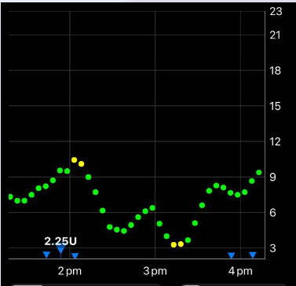 | In this example Freya is eating afternoon tea of around 20 carbs. For this meal Freya only needed 1.33U. At the start of the rise Boost gave 2.25U which subsequently resulted in a low 1 hour later.  At this stage I had an automation to increase the profile to 130% for 16min if the time is between 6.45am and 8pm.  This issue is solved by removing my automation. This has prevented Boost giving to much insulin.

Example 2:
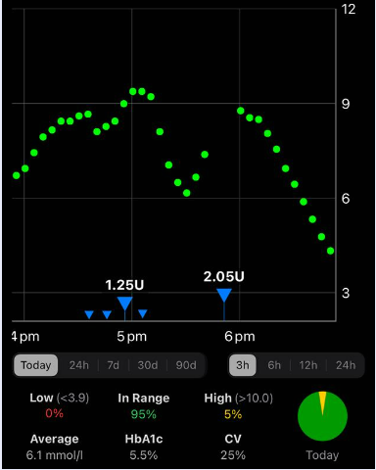 | In this example Freya is eating Dinner of 30 carbs followed by pudding of 40 carbs.  Boost has triggered at the start of the dinner rise and again at the start of the dessert rise.  Boost has easily covered 70 carbs eaten within an hour with no subsequent low or high.  Previously AAPS 3.2 on FCL would not have coped with this amount of carbs in a short period of time and Freya would be high for hours afterwards.

Example 3:
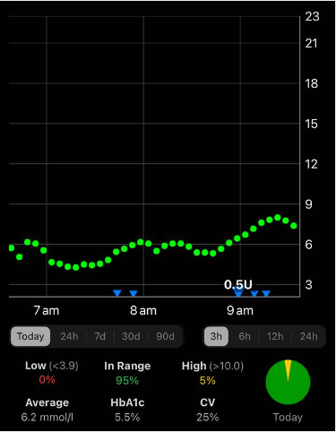 | In this example Freya has eaten a lower carb breakfast (eggs sausage, hashbrown) at 6.45am.  Boost has not triggered for a low carb breakfast. And has given the right amount of insulin for the protein rise in the hours after

Example 4:
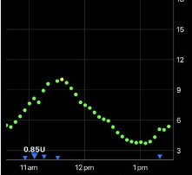 | In this example Freya is eating Lunch of about 30 fast acting carbs. Boost gives the right amount of insulin and the BGL is brought perfectly into line 2 hours+ later

Example 5:
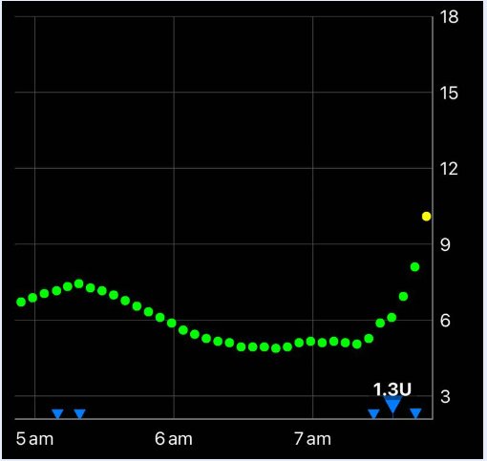 | In this example Freya’s BGL has started to rise because of Dawn Phenomenon. Then at 7am Freya has eaten Breakfast (2 x GF Weetbix & milk) of 35 carbs which are very fast acting.  Boost has not “boosted “Dawn Phenomenon and given the right amount of insulin for breakfast.

